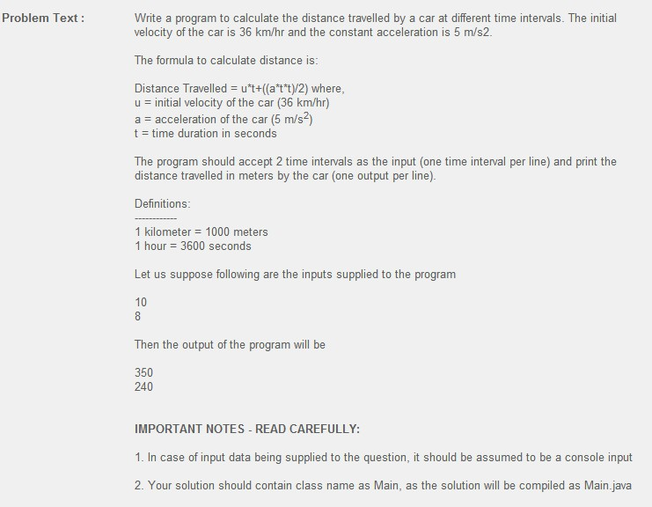

import java.io.BufferedReader;

import java.io.IOException;

import java.io.InputStreamReader;

public class Main {

public static void main (String[] arge) throws IOException{

BufferedReader reader = new BufferedReader(new InputStreamReader(System.in));

for(int i = 0; i<2 ; i++){

String tString = reader.readLine();

long t = Long.parseLong(tString);

long v= 36 * 1000/3600;

long a= 5;

long dis= v* t + (a* t*t/2);

System.out.println(dis);

}

}

}

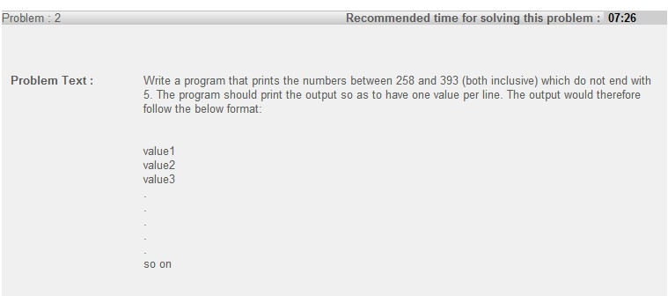

public class Main {

public static void main (String[] arge){

for(int i = 258; i<394 ; i++){

String a = ""+i;

if(!a.endsWith("5"))

System.out.println(i);

}

}

}

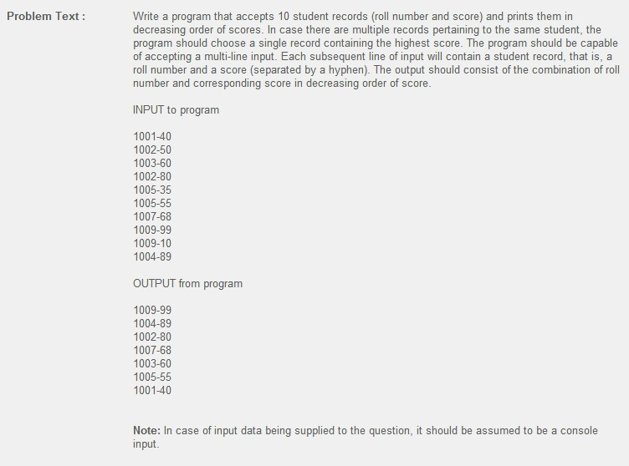

import java.io.BufferedReader;

import java.io.IOException;

import java.io.InputStreamReader;

import java.util.Iterator;

import java.util.LinkedList;

import java.util.Map;

import java.util.Map.Entry;

import java.util.TreeMap;

public class Main {

public static void main (String[] arge) throws IOException{

BufferedReader reader = new BufferedReader(new InputStreamReader(System.in));

Map<Integer,Integer> map = new TreeMap<Integer,Integer>();

for(int i = 0; i<10 ; i++){

String rec = reader.readLine();

String[] pair = rec.split("-");

int no=Integer.parseInt(pair[0]);

int score=Integer.parseInt(pair[1]);

if(map.containsKey(no)){

if(map.get(no)< score)

map.put(no, score);

}else{

map.put(no, score);

}

}

Iterator<Entry<Integer, Integer>> it = map.entrySet().iterator();

LinkedList<Entry<Integer, Integer>> ll = new LinkedList<Entry<Integer, Integer>>();

while(it.hasNext()){

Entry<Integer, Integer> entry = it.next();

int i = 0;

for ( i = 0; i< ll.size();i++){

if(ll.get(i).getValue().intValue() > entry.getValue().intValue()){

continue;

}else{

break;

}

}

ll.add(i,entry);

}

Iterator <Entry<Integer, Integer>> it2 = ll.iterator();

while(it2.hasNext()){

Entry<Integer, Integer> entry = it2.next();

System.out.println(entry.getKey()+"-"+entry.getValue());

}

}

}

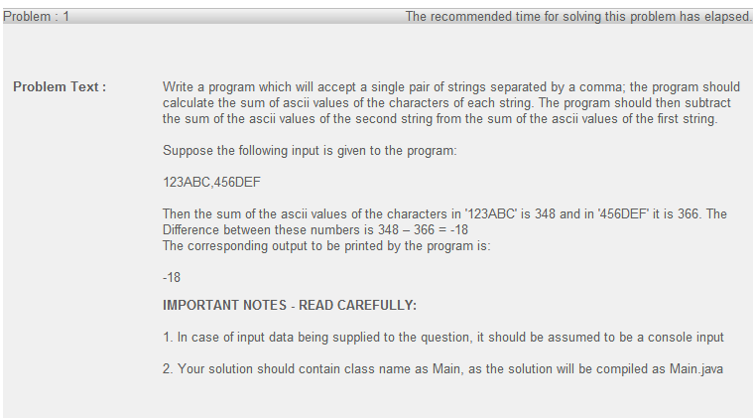

import java.io.BufferedReader;

import java.io.IOException;

import java.io.InputStreamReader;

public class Main {

public static void main (String[] arge) throws IOException{

BufferedReader reader = new BufferedReader(new InputStreamReader(System.in));

String str=reader.readLine();

String[] arr1=str.split(",");

char[] arrChar1 = arr1[0].toCharArray();

char[] arrChar2 = arr1[1].toCharArray();

int int1 = 0,int2=0;

for (int i = 0;i<arrChar1.length;i++){

int1 += arrChar1[i];

}

for (int i = 0;i<arrChar2.length;i++){

int2 += arrChar2[i];

}

System.out.println(int1-int2);

}

}

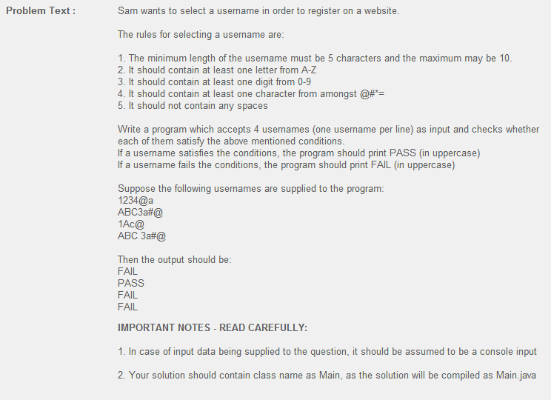

import java.io.BufferedReader;

import java.io.IOException;

import java.io.InputStreamReader;

public class Main {

public static void main (String[] arge) throws IOException{

BufferedReader reader = new BufferedReader(new InputStreamReader(System.in));

String patterm1 = "ABCDEFGHIJKLMNOPQRSTUVWXYZ";

String patterm2 = "0123456789";

String patterm3 = "@#*=";

for (int i = 0; i<4; i++){

boolean flag = true;

String input = reader.readLine();

char[]arr=input.toCharArray();

if(arr.length>10 || arr.length<5)flag=false;

int j = 0;

for(j=0;j<arr.length;j++){

if(arr[j]==' '){

flag=false;

break;

}

}

for(j=0;j<arr.length;j++){

if(patterm1.indexOf(""+arr[j])>=0){

break;

}

}

if(j==arr.length)flag = false;

for(j=0;j<arr.length;j++){

if(patterm2.indexOf(""+arr[j])>=0){

break;

}

}

if(j==arr.length)flag = false;

for(j=0;j<arr.length;j++){

if(patterm3.indexOf(""+arr[j])>=0){

break;

}

}

if(j==arr.length)flag = false;

if(flag){

System.out.println("PASS");

}

else{

System.out.println("FAIL");

}

}

}

}

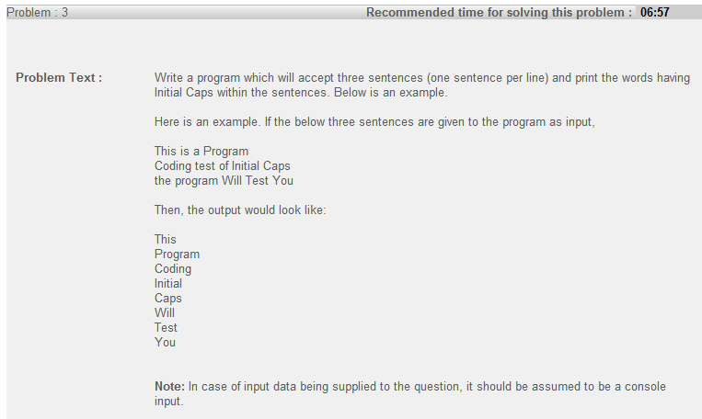

import java.io.BufferedReader;

import java.io.IOException;

import java.io.InputStreamReader;

public class Main {

public static void main (String[] arge) throws IOException{

BufferedReader reader = new BufferedReader(new InputStreamReader(System.in));

String patterm2 = "ABCDEFGHIJKLMNOPQRSTUVWXYZ";

for(int i =0;i<3;i++){

String input = reader.readLine();

String[] arr= input.split(" ");

for(int j = 0;j<arr.length;j++){

if(arr[j]!=null){

char c=arr[j].charAt(0);

if(patterm2.indexOf(c)>=0)

System.out.println(arr[j]);

}

}

}

}

}

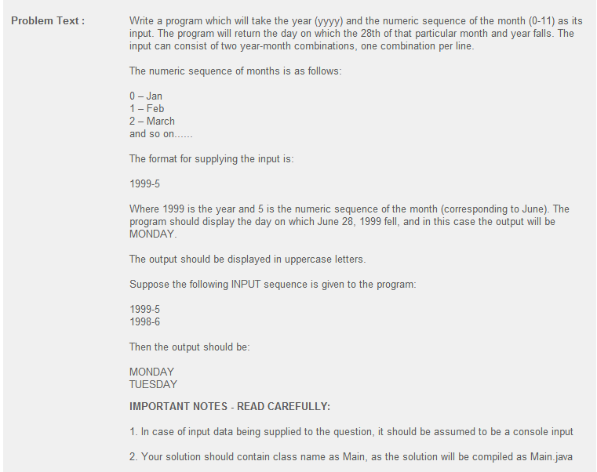

import java.io.BufferedReader;

import java.io.IOException;

import java.io.InputStreamReader;

import java.util.Calendar;

import java.util.GregorianCalendar;

public class Main {

public static void main(String[] arge) throws IOException {

BufferedReader reader = new BufferedReader(new InputStreamReader(

System.in));

String[] week={"","SUNDAY","MONDAY","TUESDAY","WEDNESDAY","THURSDAY","FRIDAY","SATURDAY"};

GregorianCalendar d = new GregorianCalendar();

for (int i = 0; i < 2; i++) {

String input = reader.readLine();

String[] arr = input.split("-");

int year = Integer.parseInt(arr[0]);

int month = Integer.parseInt(arr[1]);

d.set(Calendar.MONTH, month);

d.set(Calendar.YEAR, year);

d.set(Calendar.DAY_OF_MONTH, 28);

int weekday = d.get(Calendar.DAY_OF_WEEK);

System.out.println(week[weekday]);

}

}

}

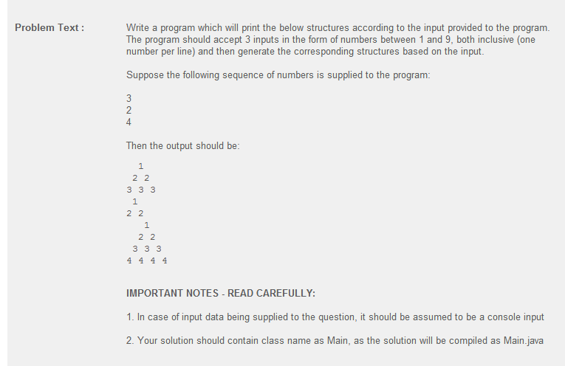

import java.io.BufferedReader;

import java.io.IOException;

import java.io.InputStreamReader;

public class Main {

public static void main(String[] arge) throws IOException {

BufferedReader reader = new BufferedReader(new InputStreamReader(

System.in));

for (int i = 0; i < 3; i++) {

String input = reader.readLine();

int value = Integer.parseInt(input);

for(int j = 1 ;j<=value;j++){

//space

for(int k = 0; k< value-j;k++){

System.out.print(" ");

}

for (int k = 0;k<j;k++){

System.out.print(j);

if(k<j-1){

System.out.print(" ");

}

}

if(j<value)

System.out.println();

}

}

}

}

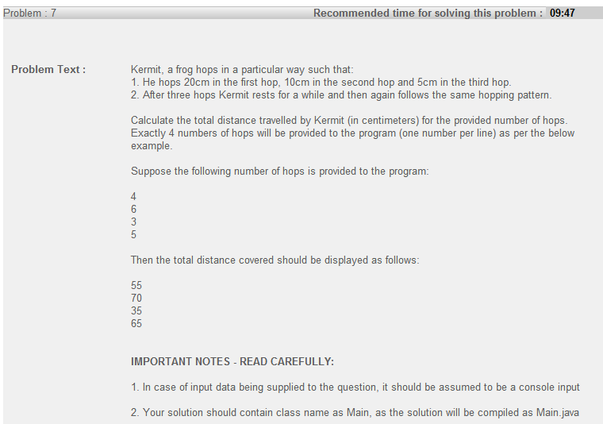

import java.io.BufferedReader;

import java.io.IOException;

import java.io.InputStreamReader;

public class Main {

public static void main(String[] arge) throws IOException {

BufferedReader reader = new BufferedReader(new InputStreamReader(

System.in));

for (int i = 0; i < 4; i++) {

String input = reader.readLine();

int hops = Integer.parseInt(input);

int round = hops/3;

int gap = hops%3;

int dis = 35*round;

switch (gap){

case 1:

dis+=20;

break;

case 2:

dis+=30;

break;

}

System.out.println(dis);

}

}

}

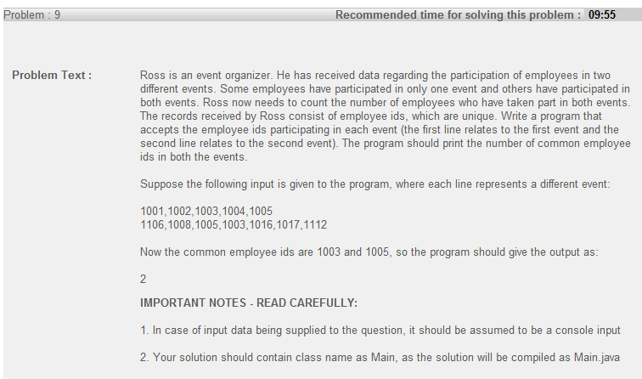

**import** java.io.BufferedReader;

**import** java.io.IOException;

**import** java.io.InputStreamReader;

**import** java.util.HashSet;

**import** java.util.Set;

**public** **class** Main {

**public** **static** **void** main(String[] arge) **throws** IOException {

BufferedReader reader = **new** BufferedReader(**new** InputStreamReader(

System.*in*));

Set<String> set = **new** HashSet<String>();

String rec = reader.readLine();

String[] pair = rec.split(",");

**for** (**int** i = 0; i < pair.length; i++)

set.add(pair[i]);

**int** count=0;

String rec2 = reader.readLine();

String[] pair2 = rec2.split(",");

**for** (**int** i = 0; i < pair.length; i++){

**if**(set.contains(pair2[i])){

count++;

}

}

System.*out*.println(count);

}

}